**Chapter 1: Introduction**

This chapter provides an overview of the project, beginning with the challenges of transforming raw learning materials into meaningful assessments and summaries. It highlights the project’s goals, scope, and boundaries, alongside the software and hardware requirements necessary for both development and deployment. In addition, it outlines the limitations, expected outputs, project schedule, and associated risks. Together, these sections establish the foundation for understanding the motivation, objectives, and constraints guiding the design and implementation of the AI-powered quiz-generation system.

**1.1 Problem Statement: Successfully Translating Raw Learning Materials into Assessments and Summaries**

The digital learning age has brought the creation of course material in a wide variety of formats, from audio and video files to PDFs, Word documents, and presentations. Translating this blended content into official quizzes and brief summaries is normally time-consuming, hard work, and prone to human error.

A majority of the existing tools are limited to one file type or must be pre-prepared beforehand by hand, which is inefficient and discourages frequent use. This creates a problem for students as well as teachers in accessing interactive, stimulating, and useful study material, thus slowing down the learning process within hectic academic as well as training environments.

**1.2 Project Goal: From Formats to Knowledge — AI for Intelligent Learning Tools**

The aim of this project is to develop an AI-driven system capable of extracting important details from various content forms and converting it into quizzes and abstracts. Through the automation of assessment and summarization, the system will help students, instructors, and self-learners save valuable time, promote active learning, and enable the easy creation of good-quality learning materials.

In the long term, the solution is designed to reduce teaching load, improve knowledge retention, and promote more individualized, adaptive learning experiences across different learning environments.

**1.3 Project Scope: Establishing the Boundaries for AI-Powered Content Transformation**

This project is designed to develop an AI system that can accept various types of content like MP3, MP4, PDF, MS Word files, and PowerPoint presentations, and perform real-time audio and video content transcription. The system will automatically generate quizzes and summaries from the inputs via an easy, intuitive web-based interface.

**1.3.1 Key Features**

1. Content parsing and intelligent file format handling
2. Natural Language Processing (NLP) to pull out major points and ideas
3. Robot quiz creation from various question types (e.g., multiple choice, true/false, short answer)
4. Fast revision-boosted summary creation

**1.3.2 Within Scope**

1. File uploading in accepted formats
2. Real-time transcriptions
3. English-language content
4. Arabic-language content
5. Exporting quizzes in common formats
6. Interactive in-platform quiz-taking

**1.3.3 Out of Scope**

1. Third-party LMS integration (e.g., Blackboard, Moodle)
2. Non-English and non-Arabic language support
3. Mobile app development in this release

**1.4 Project Software and Hardware Requirements**

**1.4.1 Hardware Requirements**

Hardware requirements can be split into two parts: requirements for development and requirements for end-users.

**1.4.1.1 Requirements for Development**

**React**

* CPU: Intel Core i3
* RAM: 8 GB
* Storage: 10 GB (Kinsta, n.d.)

**C# Development using Visual Studio IDE**

* Processor: 1.8 GHz or faster processor (dual-core or better recommended)
* RAM: 2 GB (4 GB recommended, 2.5 GB minimum on a virtual machine)
* Hard Disk Space: Up to 130 GB depending on features installed; typical installations require 20–50 GB. SSD recommended
* Video Card: Supports minimum display resolution of 720p (1280 × 720); WXGA (1366 × 768) or higher recommended (Microsoft, 2025)

**TinyLlama**

* Normally requires a minimum of 16 GB VRAM. Utilizing QLoRA reduces requirements (InsightReactions, 2025).

| **Hardware Component** | **Minimum Requirement** | **Recommended** | **Notes** |
| --- | --- | --- | --- |
| GPU VRAM | 6 GB | 8 GB+ (e.g., RTX 3070, 4060 Ti, 3080) | Most critical factor. 6 GB is the absolute minimum. |
| System RAM | 16 GB | 32 GB | Needed for loading datasets and background processes |
| Storage | ~10 GB Free | 20–50 GB Free | Space for base model (~2.2 GB TinyLlama-1.1B), datasets, adapter weights. SSD recommended |

**Table 1** Hardware requirements for running TinyLlama locally (InsightReactions, 2025).

**1.4.1.2 Hardware Requirements for End-Users**

1. CPU: 4 cores or more
2. System RAM: at least 16 GB
3. GPU: NVIDIA GPUs only, 12 GB VRAM or higher
4. Storage: 60 GB SSD (250 GB recommended for additional models)
5. Wired internet connectivity during setup; wired LAN afterwards (InsightReactions, 2025)

**1.4.2 Software Requirements**

**1.4.2.1 Requirements for Development**

1. React: Windows 10/11, Ubuntu 16, or macOS 10.10 (Kinsta, n.d.)
2. C# development using Visual Studio IDE: Windows 10/11 (Microsoft, 2025)
3. TinyLlama: Windows 10/11, Ubuntu 16, or macOS 10.10 (InsightReactions, 2025)

**1.4.2.2 Requirements for End-Users**

* Windows 10/11, Ubuntu 16, or macOS 10.10

**1.5 Project Limitations**

**1.5.1 Technical Limitations**

1. Uses an open-source model agent as a base. Internet connection required (ITU, 2025).

**Figure 1:** Global internet penetration in 2025, highlighting the 67.9% population with access (Source: ITU, 2025).

1. There is no application version of Quiz AI, which means it may not be as attractive to most of the population (GSMA, 2025).

**Figure 2:** Lack of a Quiz AI mobile app may limit user adoption, illustrated by global mobile app engagement trends (Source: GSMA, 2025).

**1.5.2 Functional Limitations**

* Unsupported: Extracting audio from video not implemented.
* Workarounds: Use third-party APIs.

**1.5.3 Security Limitations**

* No login security measures or encryption for login database.

**1.5.4 Usability & Accessibility**

* Supported file formats: txt, pdf, pptx, docx, mp3, mp4.

**1.6 Project Expected Output**

**1.6.1 Functional Outputs**

1. Responsive web dashboard
2. Notifications for processing start and completion

**1.6.2 Non-Functional Outputs**

1. Fast output time
2. 4-chapter documentation in PDF
3. GitHub repository with source code

**1.7 Project Schedule**

The project schedule outlines the key milestones, activities, and deliverables required to complete the AI-powered quiz-generation website. It ensures each stage of the development process is completed on time, with clear dependencies between tasks.

**Figure 3:** Project schedule Gantt chart illustrating key milestones, activities, and deliverables for the AI-powered quiz-generation website (Source: Project Team, 2025).

**1.8 Methodology Framework Diagram**

A methodology framework diagram is a visual representation that outlines the structured steps (the methodology) within a guiding structure (the framework) to carry out a process or research—often shown as boxes and arrows depicting stages and relationships (ResearchGate, 2008).

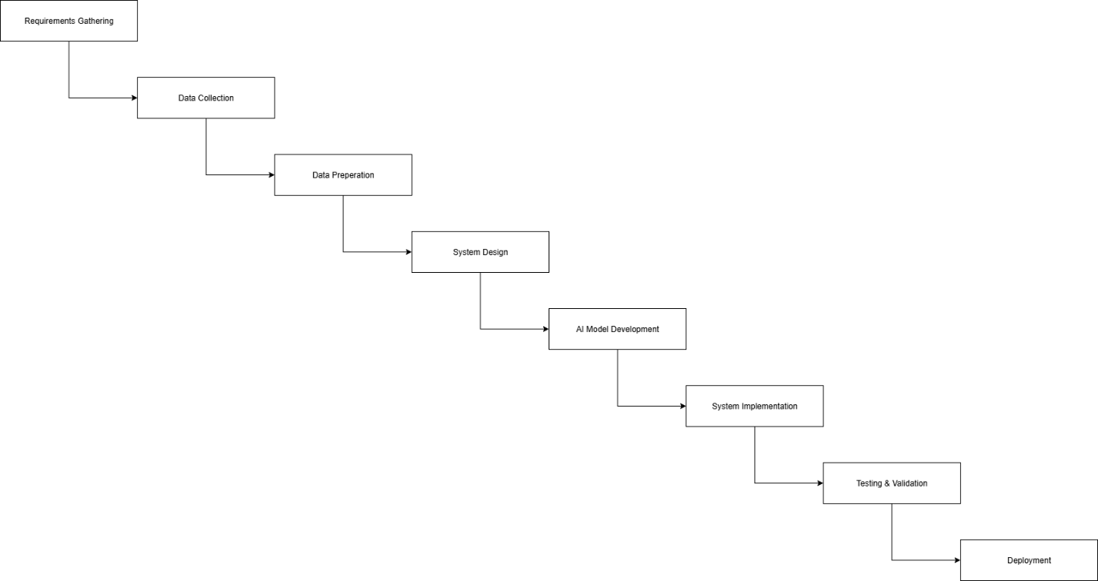

**Figure 1.2: Methodology Framework Diagram**

**1.8.1 Workflow Steps**

1. **Requirement Gathering:** Identify goals, define user roles, collect expectations.
2. **Data Collection:** Gather books, slides, notes, and other materials.
3. **Data Preparation:** Clean, organize, remove duplicates, structure topics.
4. **System Design:** Draw use case diagrams, DFDs, sequence diagrams.
5. **AI Model Development:** Build and train AI to generate quizzes, suggest topics, power chatbot.
6. **System Implementation:** Develop platform, user interfaces, integrate roles.
7. **Testing & Validation:** Test AI accuracy, usability, and system performance.
8. **Deployment:** Publish system for real users online.
9. **User Training & Documentation:** Provide manuals, guides, training for instructors and students.

**1.9 Project / Product Schedule Risks**

**1.9.1 Schedule Risk**

* Delays may occur due to AI model integration, file handling, or unforeseen bugs.

**1.9.2 Impact**

* Reduced testing time could affect stability and quality.

**1.9.3 Mitigation Strategies**

1. Begin AI research concurrently with UI/UX design.
2. Use pre-trained NLP models to speed development.
3. Implement fallback mechanisms for simplified quiz generation.
4. Add buffer periods and conduct weekly progress reviews.

**1.10 Report Organization**

* **Chapter 2** – Theoretical Background & Literature Review: Existing AI learning tools.
* **Chapter 3** – Requirements Analysis: Functional and non-functional system requirements.
* **Chapter 4** – Software Design: System architecture, database schema, UI prototypes.

**1.11 Operational Definitions**

* **System** → The Quiz AI platform.
* **User** → Any individual interacting with the system.
* **Instructor** → Uploads materials, approves content, manages quizzes.
* **Student** → Studies materials, selects topics, takes quizzes.
* **Admin** → Manages accounts, access rights, and system settings.
* **Knowledge Base** → Collection of study resources.
* **Topic** → Subject area for quiz questions.
* **Quiz** → Automatically or instructor-generated questions.
* **Question Bank** → Repository of questions.
* **Competitive Exam Mode** → Multiple students compete for points.
* **Self-Assessment** → Quiz mode with instant results.
* **Gamification** → Levels, points, badges for engagement.
* **Content Approval** → Instructor validation of AI content.
* **Exam Log** → Records of quiz attempts.
* **AI Suggestion** → Recommendations on topics and questions.
* **Voice Reading** → System reads quiz questions aloud.
* **Chatbot Assistant** → Conversational tool for content questions.
* **Tool Support** → Additional resources like calculators or whiteboards.
* **Academic Integrity** → Ensures fair quizzes/exams.
* **Data Privacy** → Protects user data.

**References**

* International Telecommunication Union (ITU). (2025). *Global internet penetration data*. <https://www.itu.int/en/ITU-D/Statistics/Pages/stat/default.aspx>
* World Bank. (2025). *Digital development: Global connectivity gaps*. <https://www.worldbank.org/en/topic/digitaldevelopment>
* GSMA. (2025). *Mobile economy report: Mobile internet trends*. <https://www.gsma.com/mobileeconomy/>
* Statista. (2025). *Digital population worldwide: Internet user forecasts*. <https://www.statista.com/statistics/617136/digital-population-worldwide/>
* Kinsta. (n.d.). *How to install React*. <https://kinsta.com/knowledgebase/install-react/>
* Microsoft. (2025). *Visual Studio 2022 system requirements*. <https://learn.microsoft.com/en-us/visualstudio/releases/2022/system-requirements>
* InsightReactions. (2025). *TinyLlama*. <https://github.com/InsightReactions/TinyLlama?tab=readme-ov-file>